CS 3610 – Spring 2014

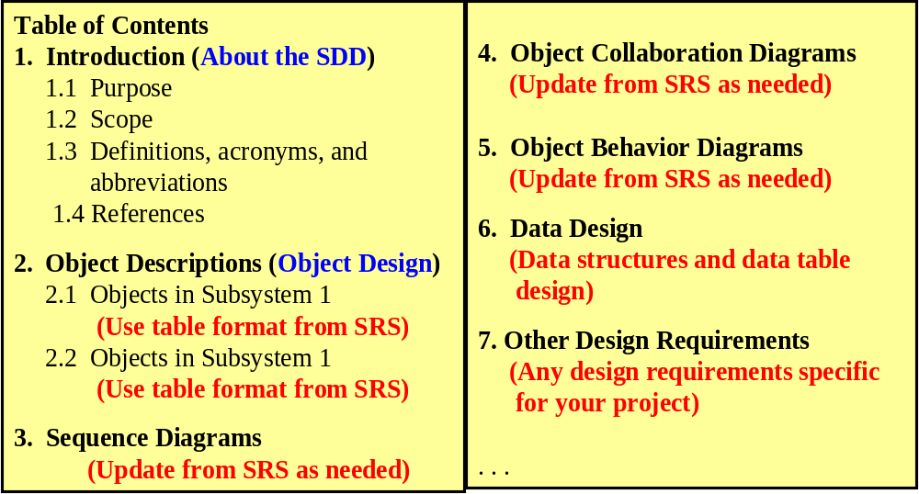
Outline of Class Project SDD
SDD Table of Content

